首先，我们可以通过谷歌地图

搜索

，

售卖汽车，摩托，

飞机、轮船、医院等地方

名称，现在假设想找的是西雅图的摩托车店，那么我们就直接在谷歌地图搜索：西雅图摩托车店

First, we can search on Google Maps to sell cars, motorcycles, airplanes, ships, hospitals and other place names.

Now let’s say we want to find a motorcycle shop in Seattle, so we can search directly on Google Maps: Seattle motorcycle shop.

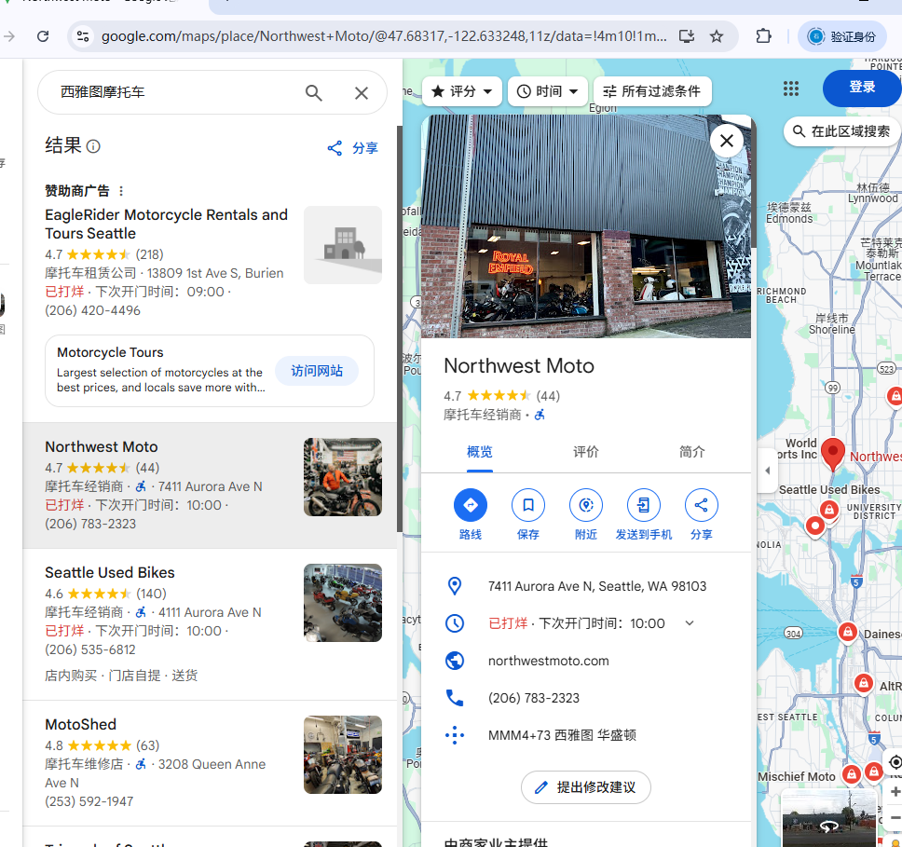

然后将我们搜索的信息复制到FB的搜索栏，

Then copy the information we are searching for into the search bar on FB.

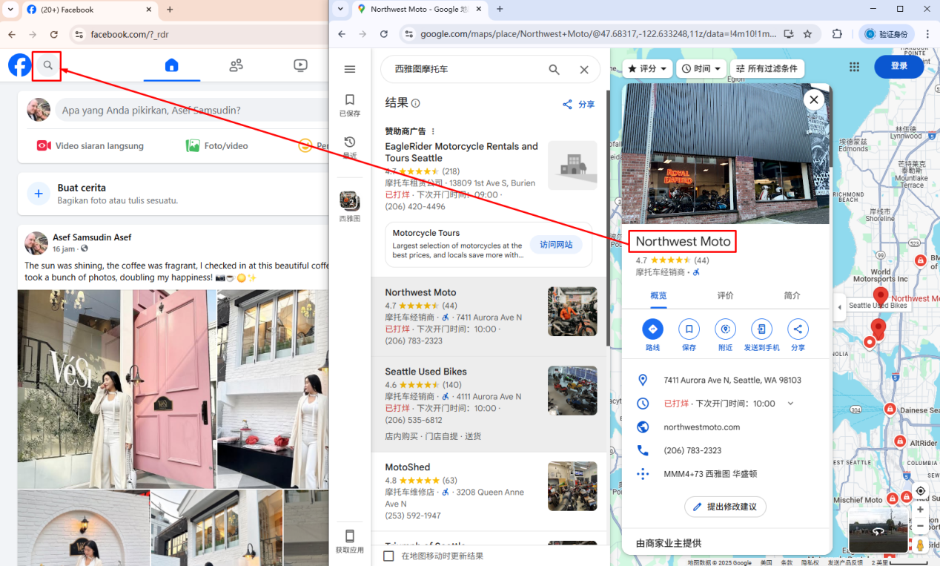

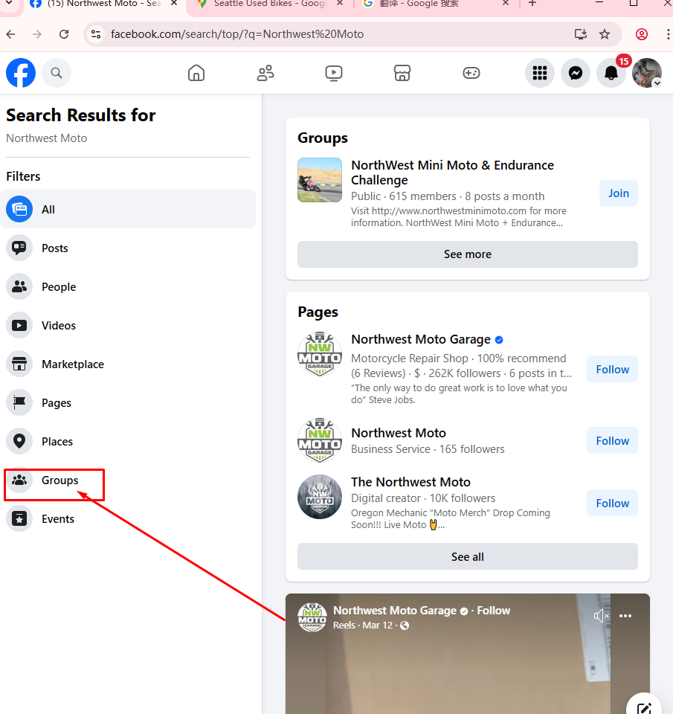

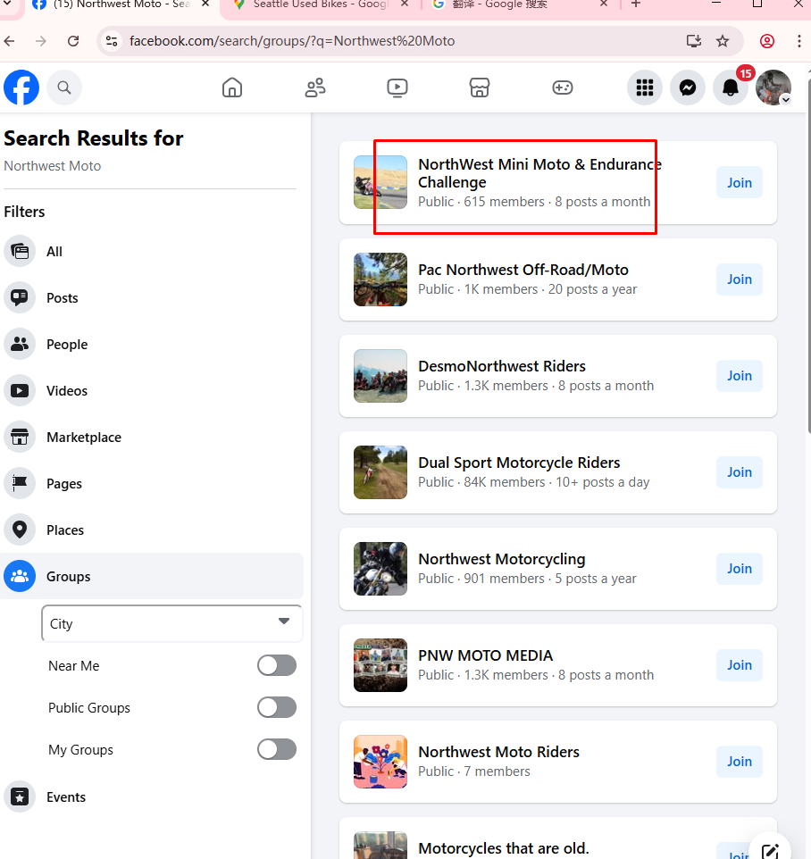

点击我们寻找的群组

有很多群组属于私密群组，我们无法查看信息，所以我们需要找到公开群组。成员数量在5k以内。

Click the group we are looking for

There are many private groups, and we cannot view the information, so we need to find a public group. The number of members is within 5k.

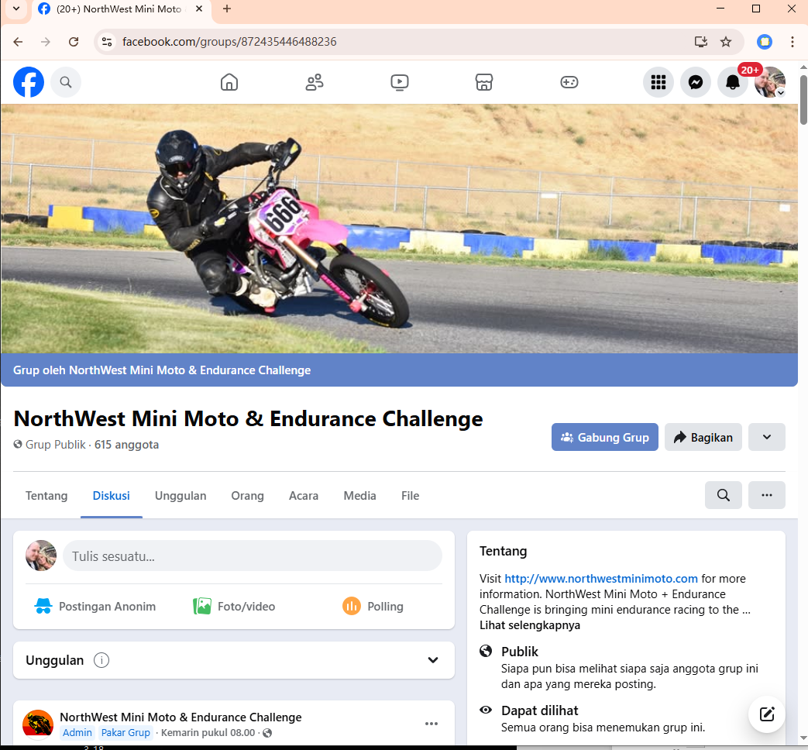

现在我们可以看到群组中的所有信息（群组成员发布的帖子，群组中有多少成员）

Now we can see all the information in the group (posts posted by group members, how many members are there in the group)

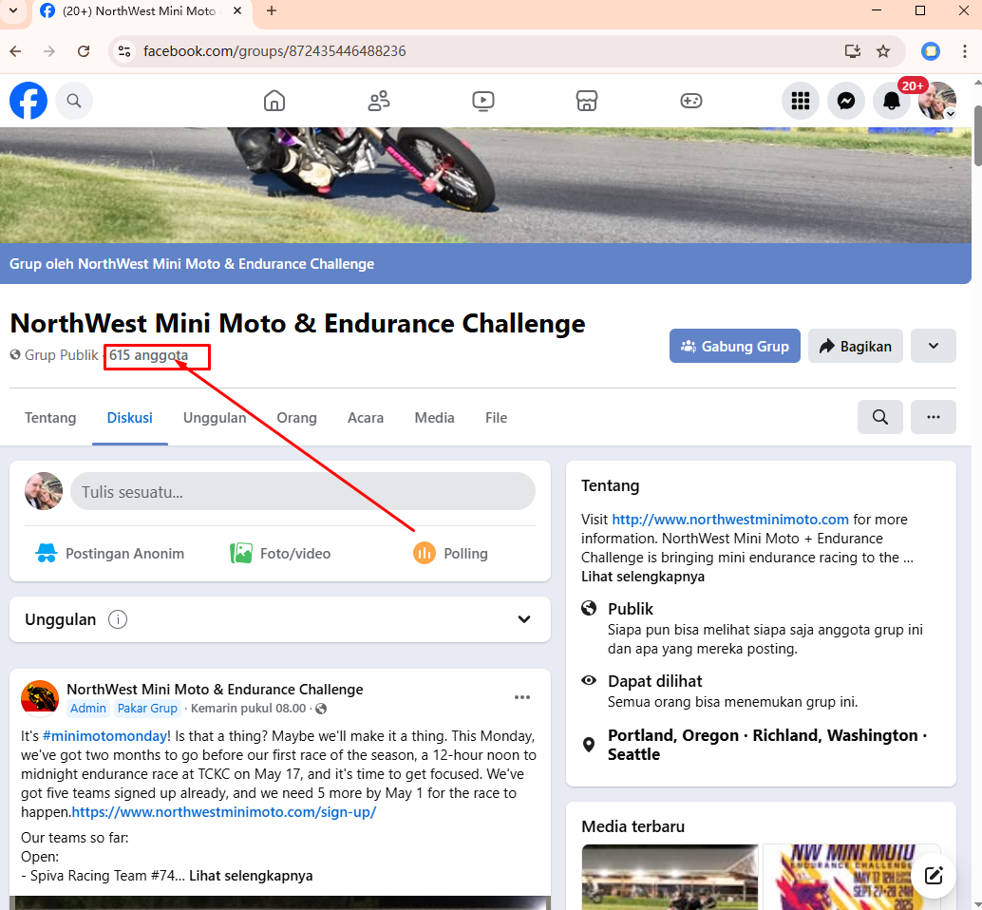

点击人数我们就可以看到群组中的所有成员

Click on the number of people to see all the members in the group

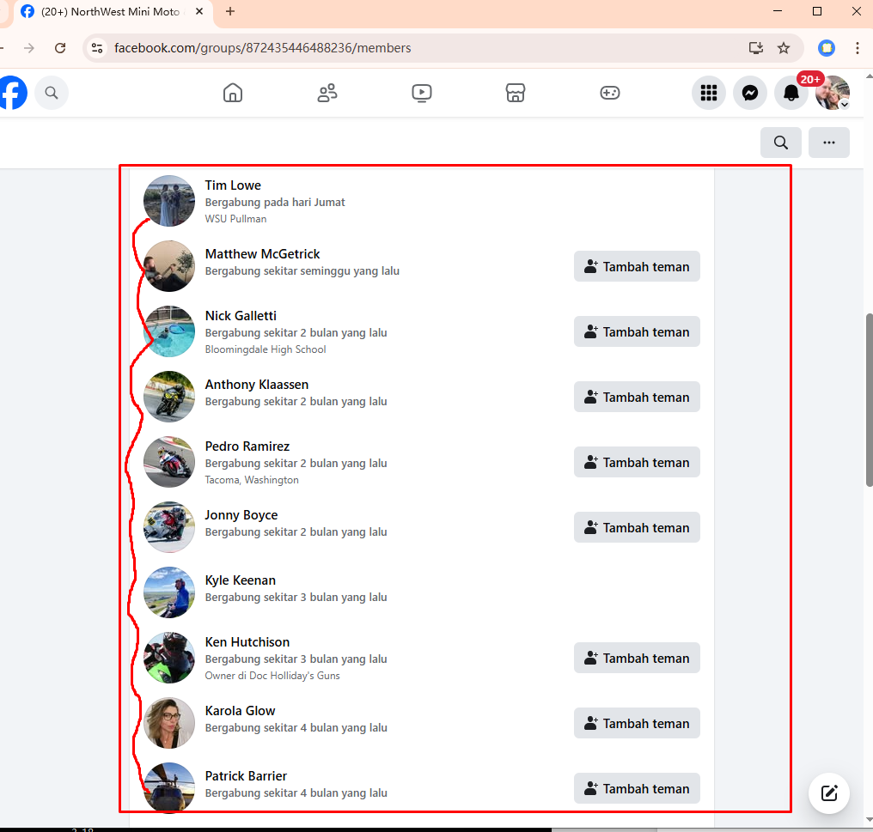

现在我们只需要挨个点击查看客户的信息，

Now we just need to click to view the customer's information one by one.

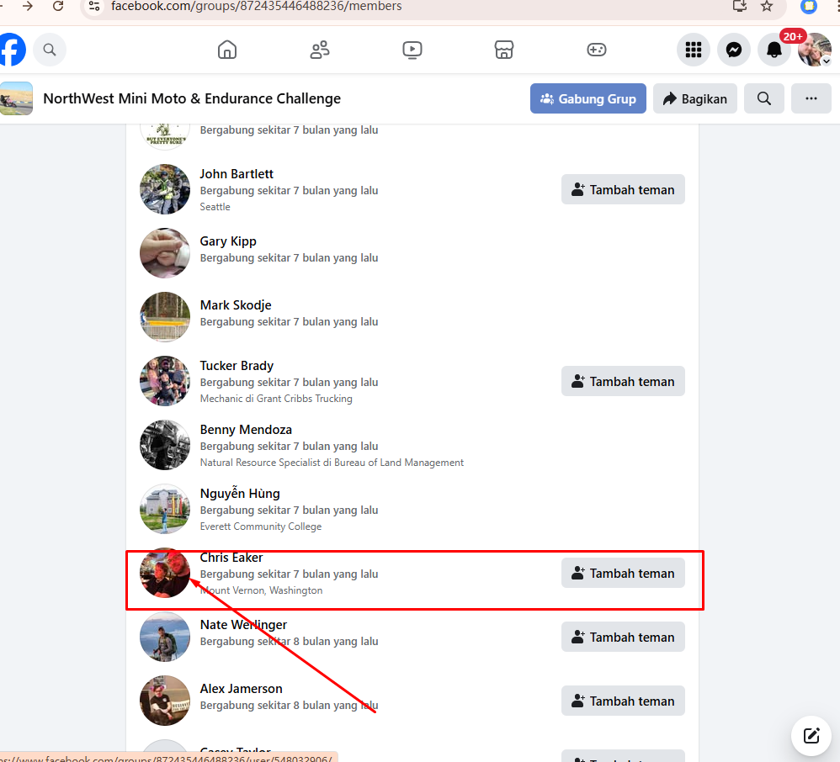

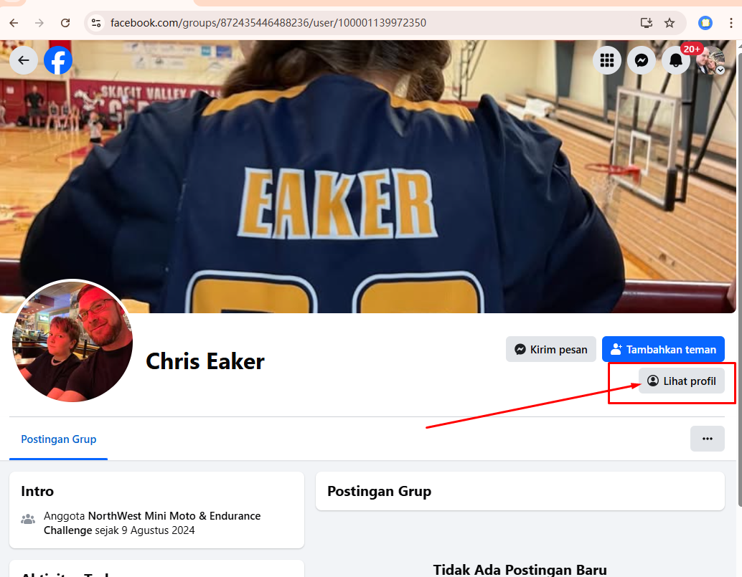

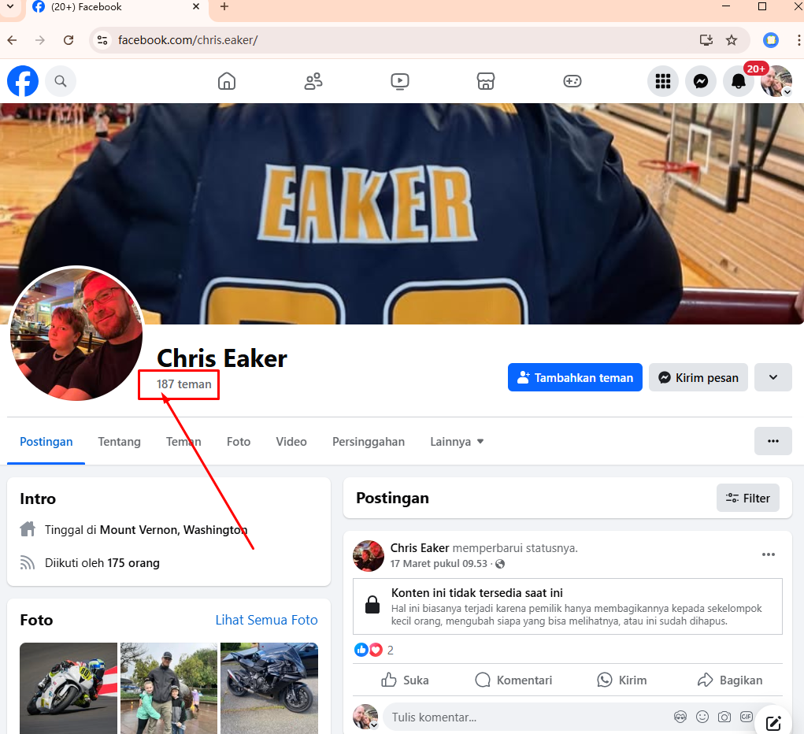

首先我们的要求是，美国男性，年龄在40岁以上，帖子内容看起来比较丰富，有钱

好友少于500个，且关注中不可以有我们的同行

First of all, our requirements are that the applicant must be an American male, over 40 years old, have a relatively rich post, and be wealthy. The applicant must have less than 500 friends and cannot be one of our peers among the followers.

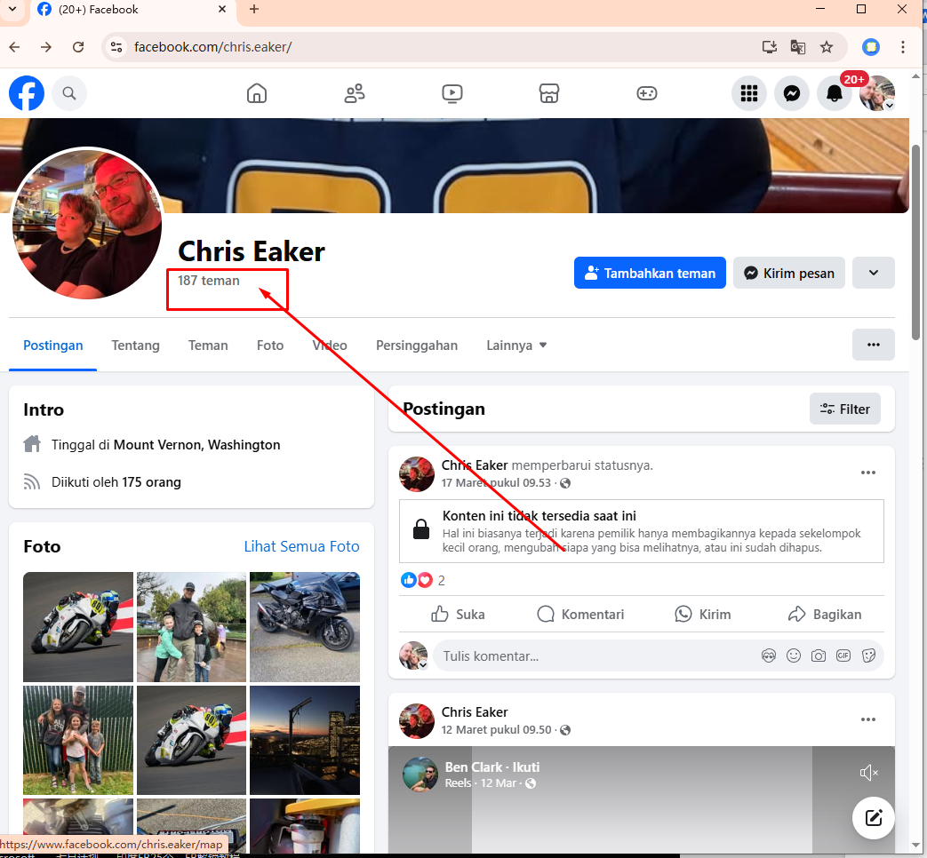

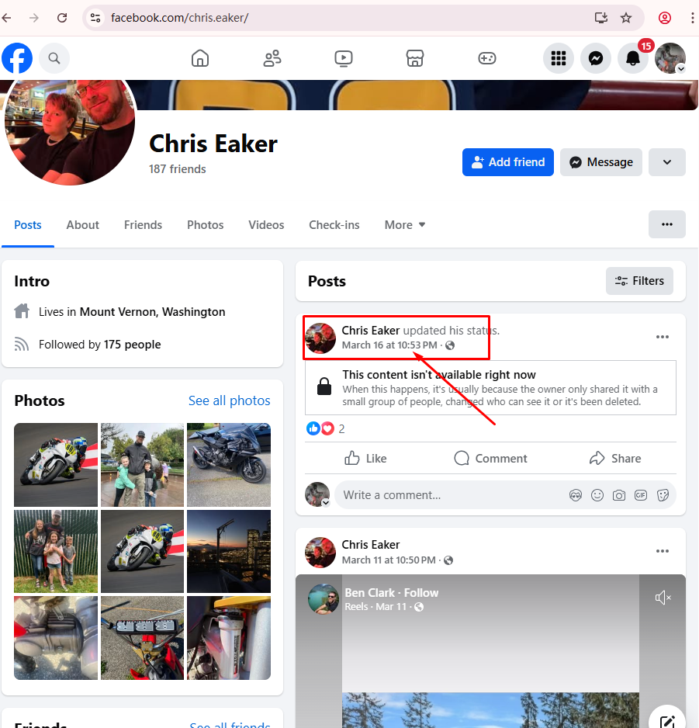

客户最后一次发帖时间需要在5个月以内。

如果客户符合我们的标准，那么我们需要检查客户的好友是否有我们的同行

The customer's last posting time must be within 5 months.

If the customer meets our criteria, we need to check whether the customer's friends have any of our peers.

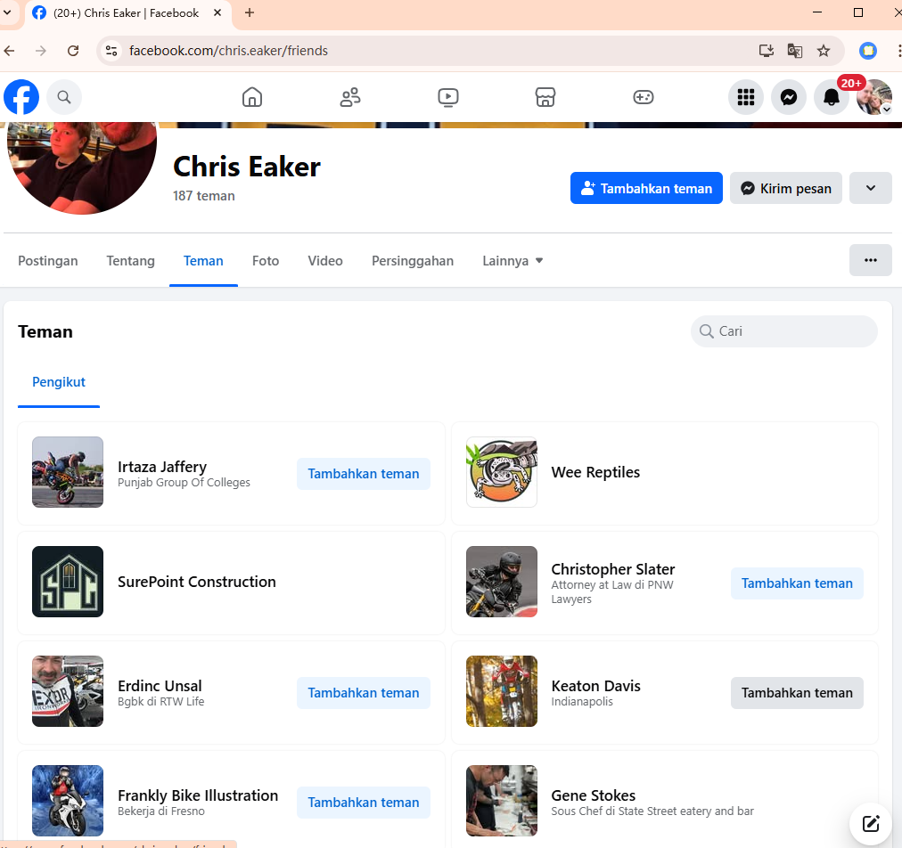

经过检查，这个客户的好友中没有我们的同行，那么符合我们的标准

如果客户好友中有我们的同行，或许好友超过500人，直接pass

After checking, if there is no one in our industry among the customer's friends, then it meets our standards

If there is one in our industry among the customer's friends, or if there are more than 500 friends, directly pass

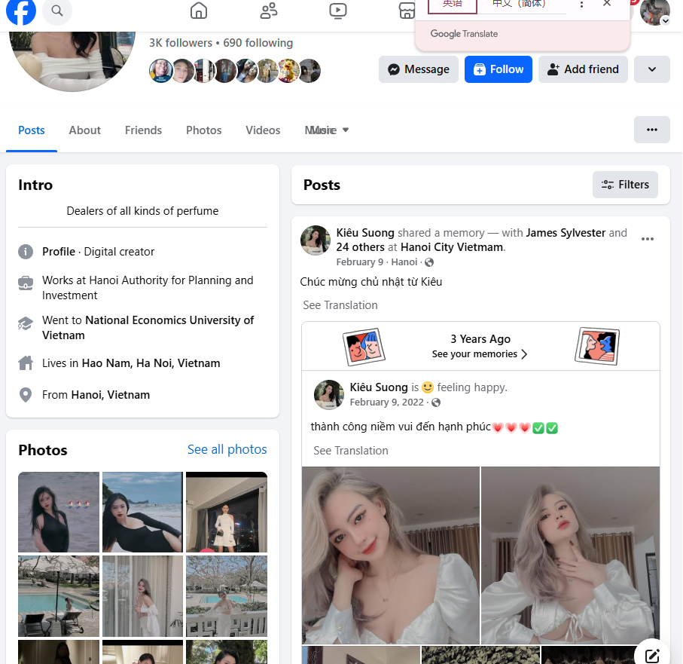

[一键保存到个人文档](javascript:;)